Dhivya Sri I
(192512487)

2a. MASKING AND SETTING OF LOWER NIBBLES ON GIVEN DATA
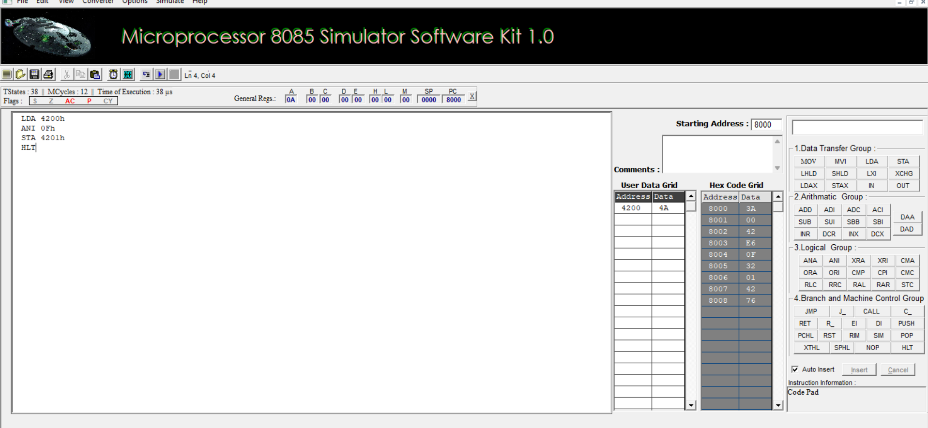
2b) SETTING OF BITS ALGORITHM:
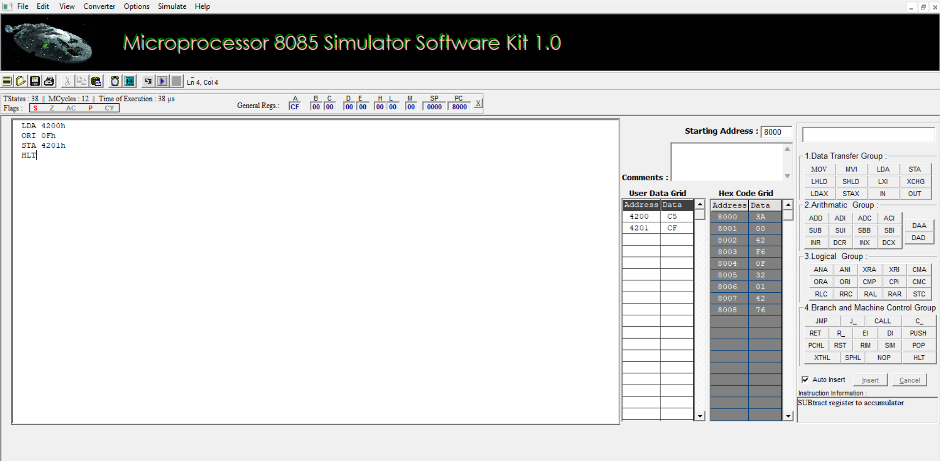

2c.ONE’S AND TWO’S COMPLEMENT
